# Roll-Pitch-Yaw

Roll, pitch, and yaw are the angles of rotation around the x, y, and z axis. The terms are generally applied to the axes of an airplane:

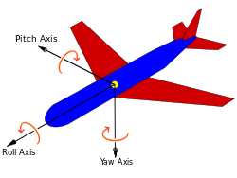

* roll is the angle around the axis going from the nose of the plane to the tail,
* yaw is the angle around the axis going from the bottom to the top of the plane
* pitch is the angle around the axis going from wing tip to wing tip

In ILB these angles are associated to how the faces are oriented:

* Roll: the angle the face is rotated around axis representing depth (into/out of the screen).

A 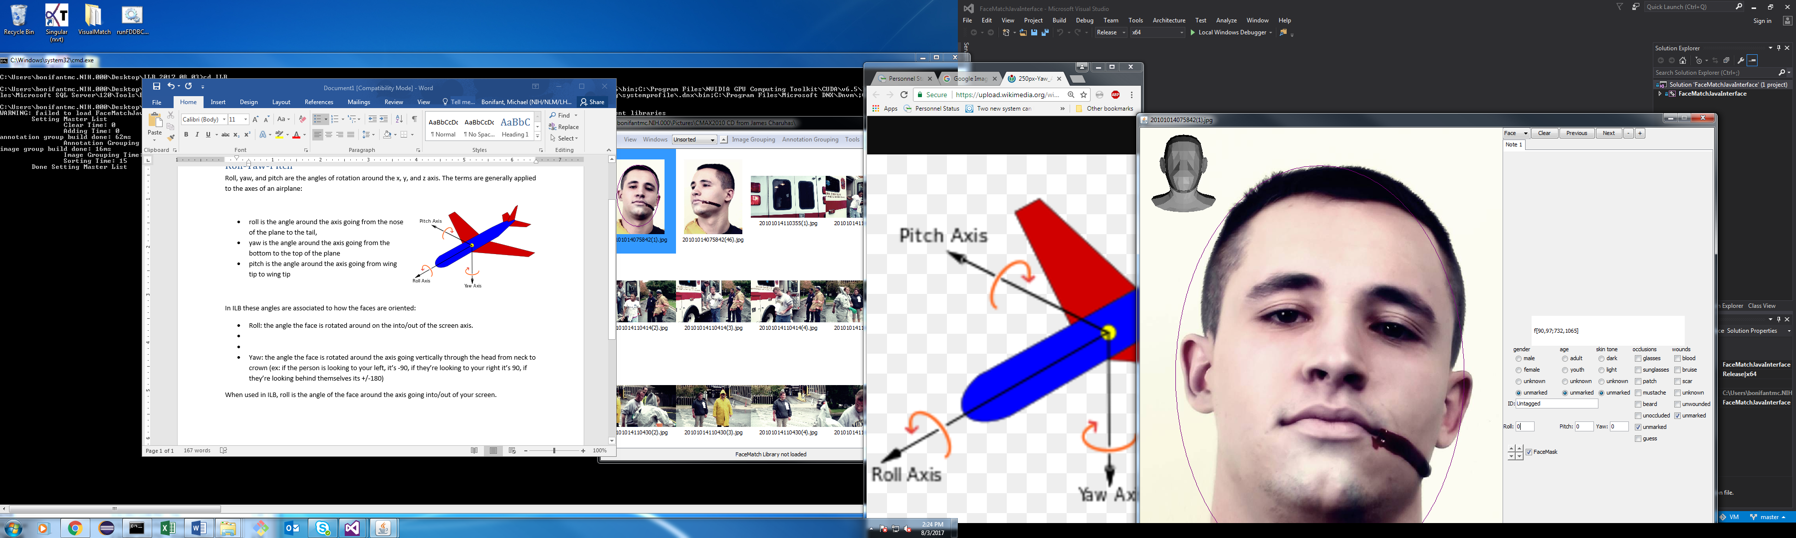 B 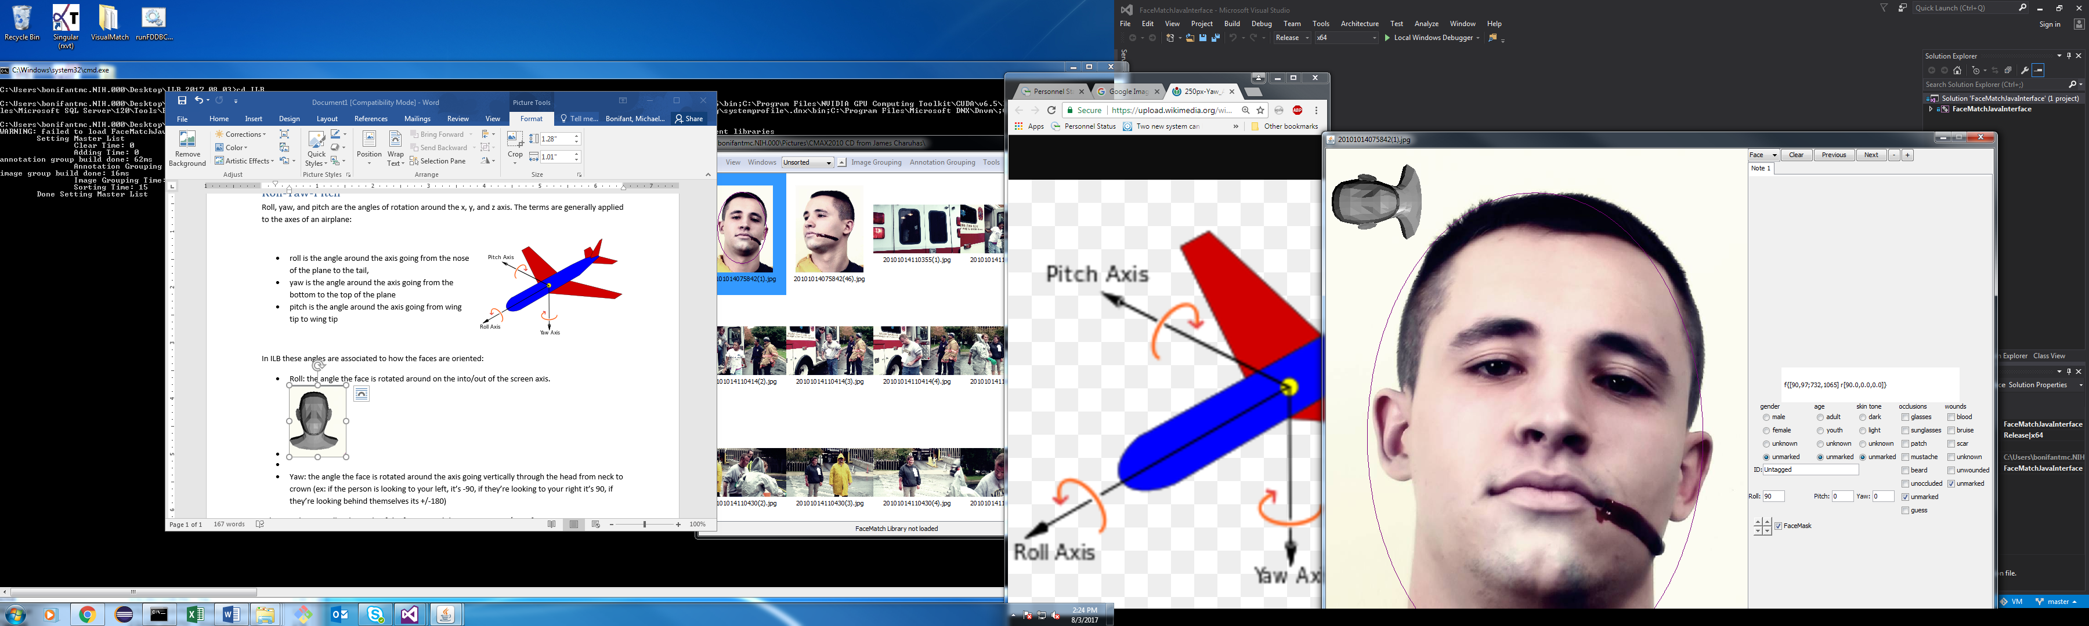 C  D 

In A the roll is 0, in B the roll is 90, in C the roll is -90, and in D the roll is ±180)

* Pitch: the angle the face is rotated around the horizontal axis.

A  B 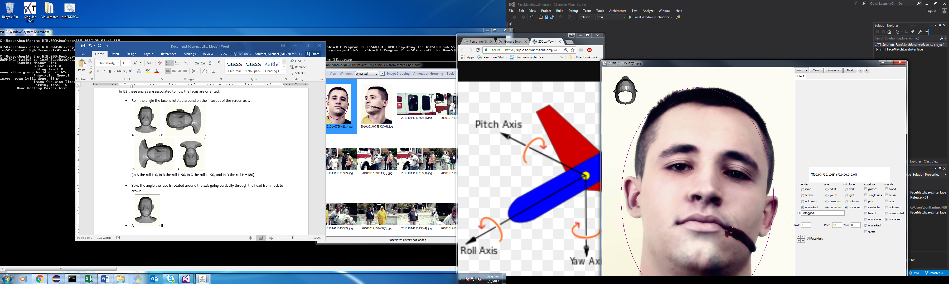 C 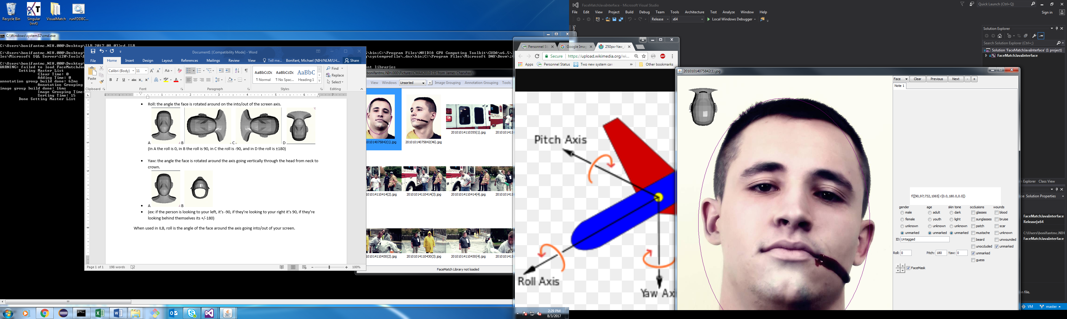 D 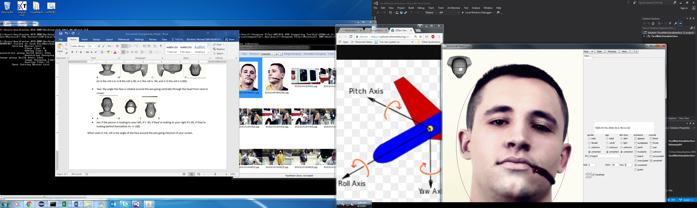

In A the pitch is 0, in B the pitch is 90 (the person is looking up, their neck is pointing out of the screen, and the top of their head is pointing into the screen), in C the pitch is ±180, and in D the pitch is -90. (the person is looking down, the top of their head is pointing out of the screen, and their neck is pointing into the screen).

* Yaw: the angle the face is rotate around the center of their head vertically.

A  B 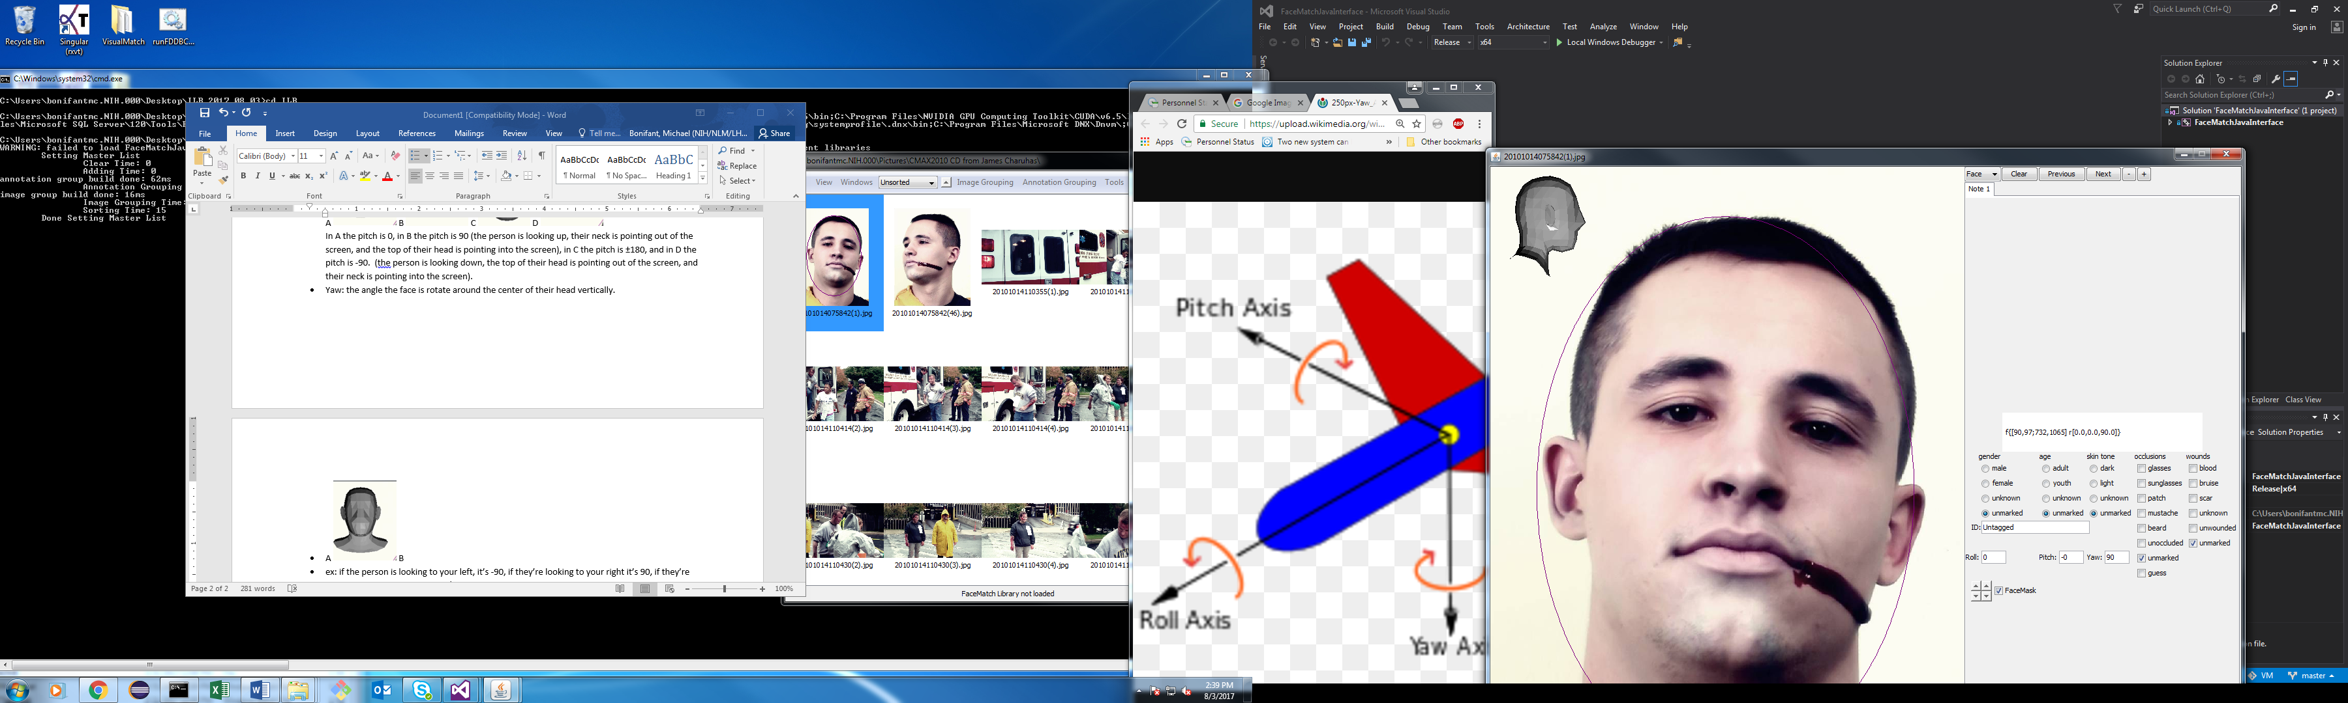 C 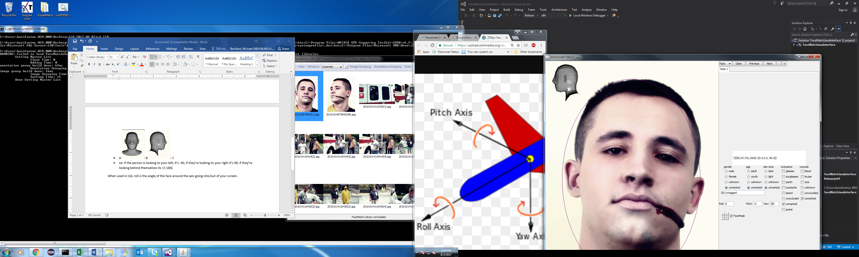 D 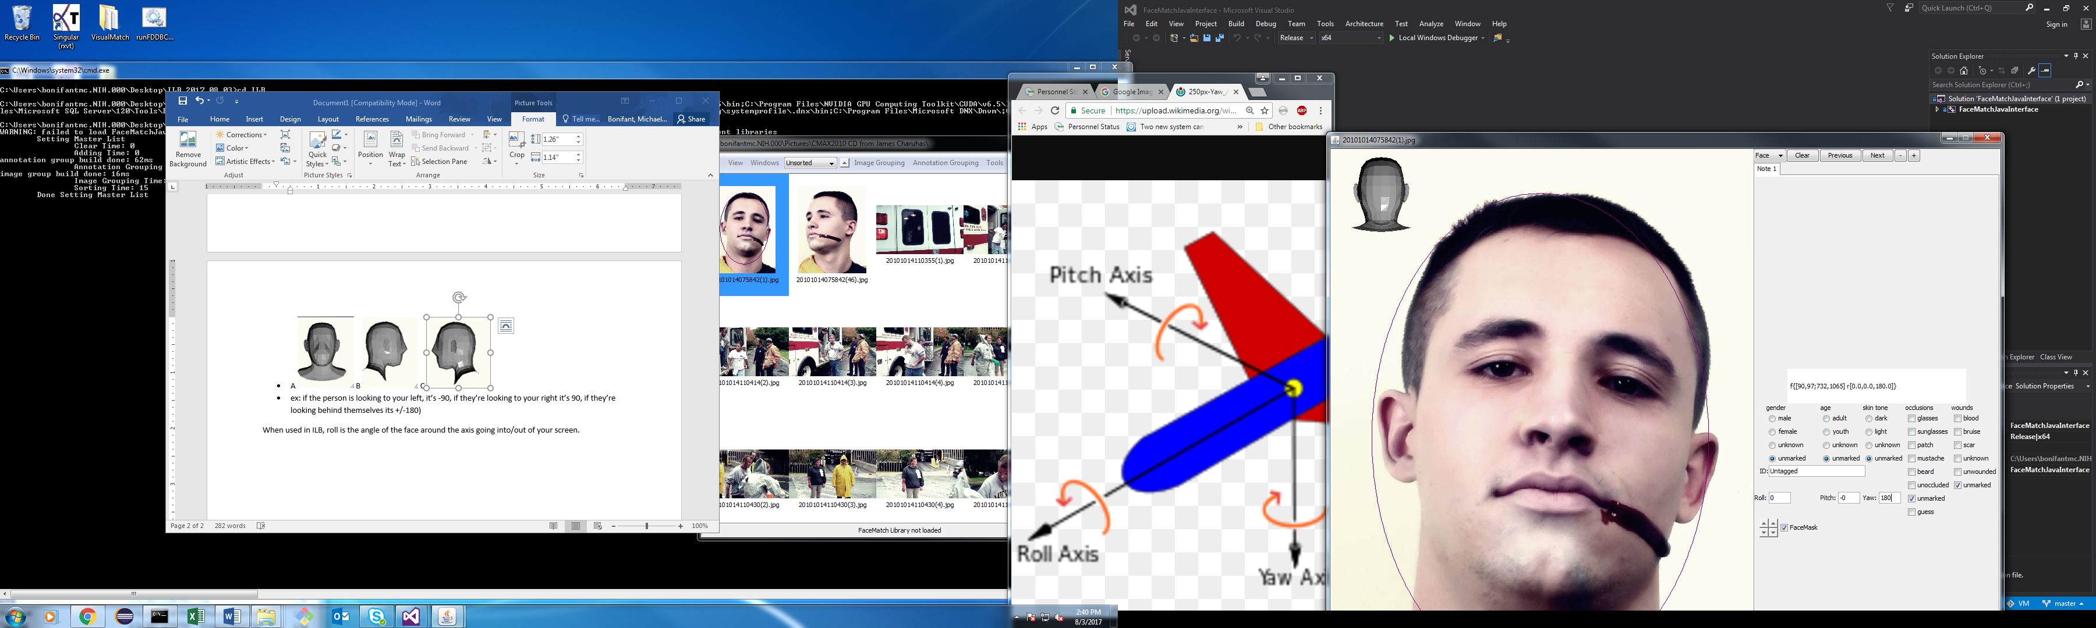

In A the pitch is 0, in B the pitch is 90, in C the Pitch is -90, and in D the pitch is ±180.

# Adjusting Roll-Yaw-Pitch in ILB

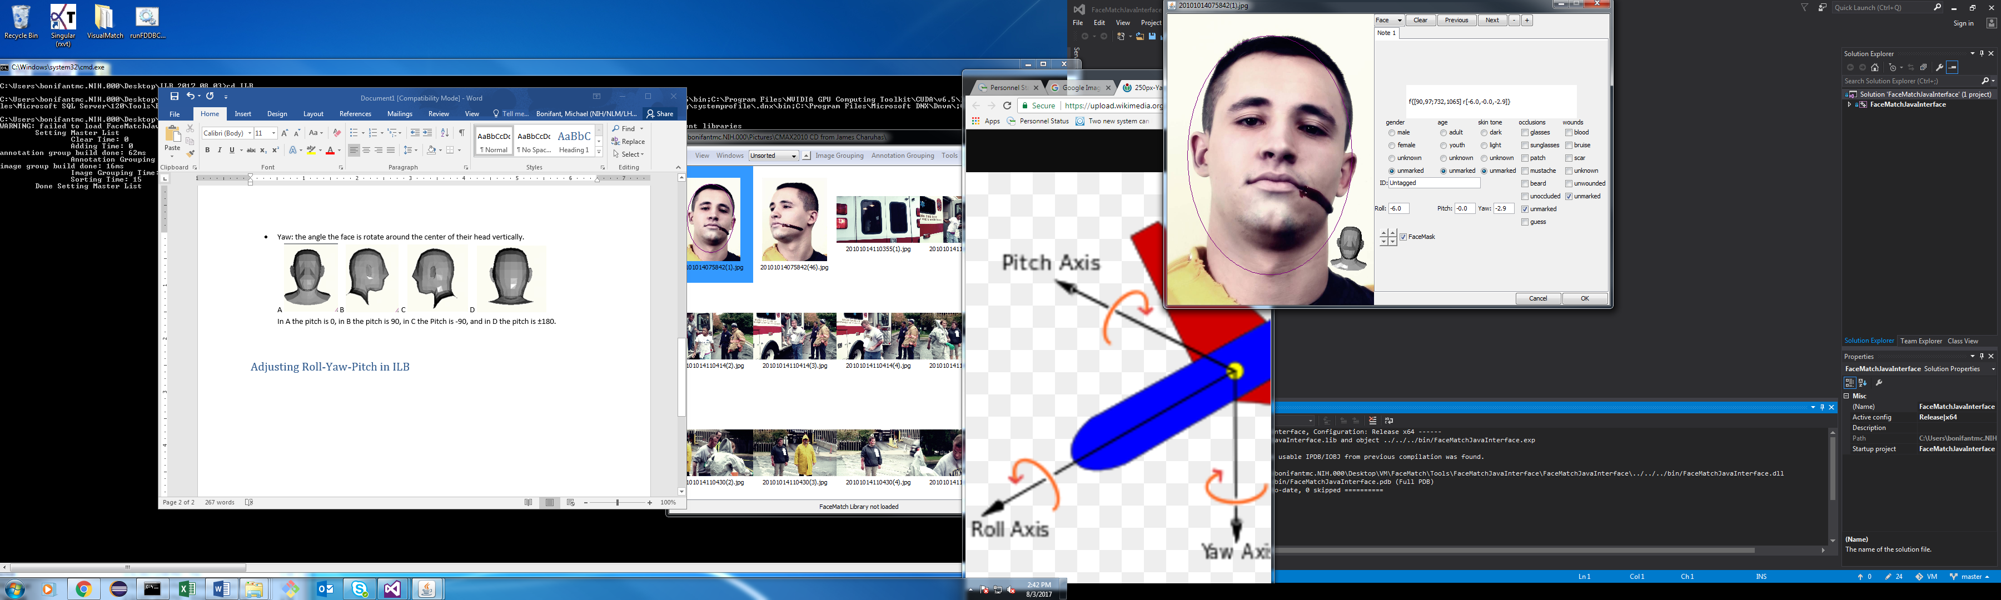

## Method 1: Textfields:

You can click into the labeled roll-yaw-pitch fields and type numbers. This will cause a head ‘FaceMask’ to appear on screen. It will rotate to match the angle you type in. You can also scroll the values up and down when in the field with the wheel on your mouse to increase or decrease the value. When you leave the roll-yaw-pitch fields, the head will disappear (unless the ‘FaceMask’ box is checked).

## Method 2: Click and Drag

If you check the box marked ‘FaceMask’ the little 3D head will stay on screen and block you from drawing new annotations. Instead when you click and drag with the **primary button** (ie: the **left button** on most mice) the face will **rotate**, the **pitch** and **yaw** adjusting based on how off center from the head the mouse has moved.

If you click and drag the **secondary button** (the **right button** on most mice), the head will **move** across the screen allowing you to relocate it.

If you spin the **mouse wheel**, the head’s **size** will expand or shrink accordingly.

If you spin the **mouse wheel** while holding the ‘**Ctlr’** button, the head’s **opacity** will adjust from either fully solid to entirely see-through.

If you spin the **mouse wheel** while holding the ‘**shift’** button, the **roll** will update.

(You can also adjust the **size** of the head with the first up/down arrows in the bottom row, and the **opacity** with the second up/down arrows, between the size buttons and the FaceMask checkbox.)